Lab Report

Lab – 01

Submitted To:

Sadia Zaman Mishu,

Assistant Professor, CSE, RUET.

Submitted By:

Anika Tabassum Era

Section: C

Roll: 1703176

**Experiment No:** 01

**Experiment Title:** Write a program to (a) prompt the user, (b) read first, middle and last initials of my name, (c) convert them in lower cases

**Code:**

.MODEL SMALL

.STACK 100H

.DATA

A DB 0AH,0DH, 'ENTER THREE INITIALS: $'

.CODE

MAIN PROC

MOV AX, @DATA

MOV DS, AX

LEA DX, A

MOV AH,9

INT 21H

MOV DL,0DH

MOV AH,2

INT 21H

MOV DL, 0AH

MOV AH, 2

INT 21H

;CHAR 1

MOV AH,1

INT 21H

MOV BL,AL

ADD BL,20H

MOV AH,2

MOV DL,BL

INT 21H

MOV DL,0DH

MOV AH,2

INT 21H

MOV DL, 0AH

MOV AH, 2

INT 21H

;CHAR 2

MOV AH,1

INT 21H

MOV BL,AL

ADD BL,20H

MOV AH,2

MOV DL,BL

INT 21H

MOV DL,0DH

MOV AH,2

INT 21H

MOV DL, 0AH

MOV AH, 2

INT 21H

;CHAR 3

MOV AH,1

INT 21H

MOV BL,AL

ADD BL,20H

MOV AH,2

MOV DL,BL

INT 21H

MOV DL,0DH

MOV AH,2

INT 21H

MOV DL, 0AH

MOV AH, 2

INT 21H

MOV AH, 4CH

INT 21H

MAIN ENDP

END MAIN

**Output:**

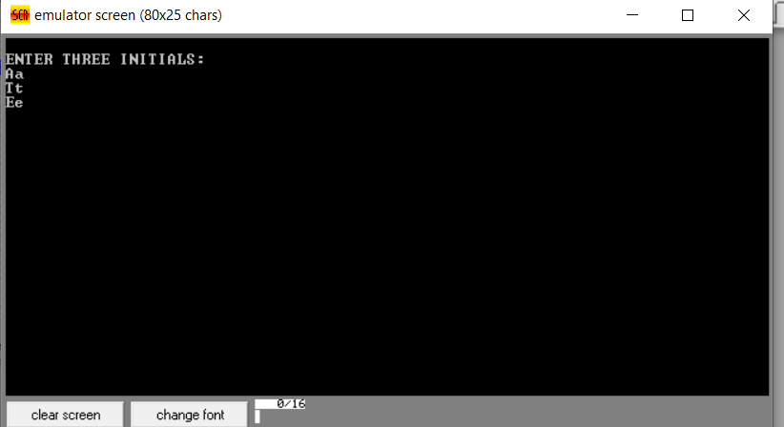

**Discussion:**

The major problem that was faced, was during the display of the prompt line. Technically the “$” sign was missed during the typing of command. So a message was popping from the emulator constantly.

Other than this the whole code ran successfully as expected.